ISD Senior School Libraries

Searching and Researching Tips & Tricks

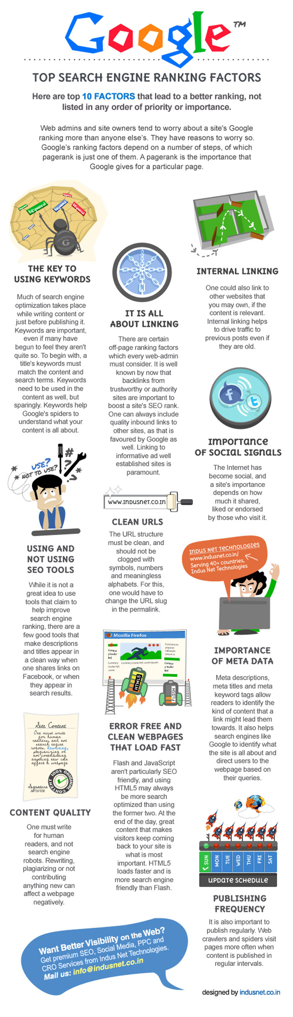

☑ Why Google Advanced?
Will change the way you search! Puts you in charge of what you find

➔try Iranian politics in a normal Google search – you get the Western point of view

➔try this in Google Advanced:

- all these words: Iranian politics
- language: English
- region: Iran (same as a .ir search)
- last update: past 24 hours

You can also search by format, reading level, usage rights, exact phrase, etc.

☑ Searching for Quality Resources:

ISD eResources
Navigate to:

- Firefly
- Senior School
- SrS Library
- eResources

Here, you’ll also find the school’s EasyBib Pro account

We have eResources in: History, Geography, Art, Music, current affairs, online databases, social issues, encyclopaedia, video resources, Spanish encyclopaedia

☑ Searching Library Resources:

Destiny catalogue (from home)
Navigate to:

- Firefly
- Senior School
- SrS Library
- Destiny

Click on Senior School and LRC
Click on Login
User name: your ISD email address
Password: your Library number

➔Type in ebook science

☑ Searching Google:

Search for an exact term using speech marks:
➔ “collateral damage”
➔ “axis of evil"
➔ “intelligence community”

Search for a term, but remove certain hits, using - (works like the Boolean operator NOT)
➔dewey -classification
➔Weimer -Republic

Google Advanced Image
Safe Search
Google Images:
➔try sexual reproduction with and without
➔try sexually transmitted diseases with and without

From Thursday:
➔Apple fruit (Search Tools… colour… black and white)

Search a site or domain
➔site:bbc.com/news Libya
➔domain:bbc.co.uk Libya

Search for sites that link to a particular website (can help with checking for reliability)
➔link:guardian.co.uk

Use truncation (*) to find words that start with certain letters (also called the wild card)
➔tech*
➔immuni*
➔Be careful with letter strings that are too short or vague:
➔gre*

To find similar sites
➔related:amazon.co.uk
The first hit is eBay

To find a definition
➔define: juxtaposition

To search for a YouTube video
➔youtube:video tutorial teaching algebra

To search by filetype
PDF
➔filetype:pdf economic terms

Excel
➔filetype:xls budget

Powerpoint
➔filetype:ppt banned books

Google Earth
➔ filetype:kmz New Britain

Word
➔filetype:doc victorians

To search in only the text or the title
➔allintitle: axis of evil
➔allintext: axis of evil

For the experts!
➔filetype:pdf allintext: "axis of evil"

Things to play around with:

Google advanced image search
Wolfram Alpha
Handwriting search on the iPad (open Google on an iPad, click on the gear icon, then ‘search settings’, then enable ‘handwrite’, then save)

Search for Formats
cell diagram
silly cats album
exports graphic
China map
Population growth infographic

☑ If you’re really interested, try these different search engines:

http://www.mahalo.com/category/language for hand picked search hits
http://www.wolframalpha.com for data and maths
http://www.clusty.com for deep or obscure information
http://www.webopedia.com for IT pros
http://archive.org/index.php archives of past webpages/wayback machine
http://www.networksolutions.com/whois/index.jsp to find out the background of a website

☑ To learn more about how to use Google in different languages:

English: http://www.google.com/insidesearch/tipstricks/
Deutsch: http://www.google.com/intl/de/insidesearch/tipstricks/
Francais: http://www.google.com/intl/fr/insidesearch/tipstricks/
Espanol: http://www.google.com/intl/es/insidesearch/tipstricks/

Things to do today:

Today is all about YOU and YOUR needs, as well as the needs of YOUR students:

➔ Make sure that you can easily:

- Get to DESTINY, the Library catalogue, and sign in to your account
- Get to the LIBRARY WEBSITE
- Get to the eRESOURCES page

➔ Try out Google Advanced

➔ Try out some of the search tips

➔ Check out some of the alternative search engines

➔ Learn more about Google Search using one of Google’s docs on this subject

➔ Search by format (diagram, infographic, etc.)

Email me if you’d like to book a 1-to-1 session, or if you have a question

Stuart Crouch
November 2014

