- 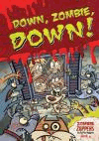 Unlimited copies Checkout / Hold
- Reading List Down, zombie, down! Higgins, Nadia. Info Open Book "The Zombie Zappers jump back into action when a unique zombie outbreak spreads to their hometown. Leo will have to join... Average Rating Reviews: 0
- 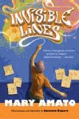 1 of 1 available Checkout / Hold
- Reading List Invisible lines Amato, Mary. Info Open Book Coming from a poor, single-parent family, seventh-grader Trevor must rely on his intelligence, artistic ability, quick... Average Rating Reviews: 0
- 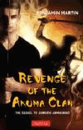 1 of 1 available Checkout / Hold
- Reading List Revenge of the Akuma Clan Martin, Benjamin, 1984- Info Open Book American teen David Matthews, an exchange student and a Jitsugen Samurai able to take on the form of Kou, the tiger god... Average Rating Reviews: 0
- 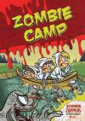 Unlimited copies Checkout / Hold
- Reading List Zombie camp Higgins, Nadia. Info Open Book "Get to know Zombie Zappers Leo, Chad, and the rest of the gang as they try to solve the mystery of the Smellerd zombies... Average Rating Reviews: 0
- 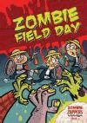 Unlimited copies Checkout / Hold
- Reading List Zombie field day Higgins, Nadia. Info Open Book "Join the Zombie Zappers back at school for the next round of zombie mayhem. When Rotfield Middle School students start... Average Rating Reviews: 0
- 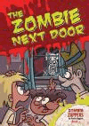 Unlimited copies Checkout / Hold
- Reading List The zombie next door Higgins, Nadia. Info Open Book "What if your next-door neighbor were a zombie? The Zombie Zappers return to find out exactly why Leo's neighbor is... Average Rating Reviews: 0
- 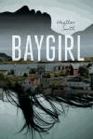 1 of 1 available Checkout / Hold
- Reading List Baygirl Smith, Heather, 1968- Info Open Book "There's no escaping the facts. Kit's father is a drunk and her mother won't stand up for herself. Kit's old life was bad... Average Rating Reviews: 0
- 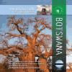 1 of 1 available Checkout / Hold
- Reading List Botswana Wittmann, Kelly. Info Open Book Provides information about the history, geography and natural resources, government, economy, people, culture, and cities... Average Rating Reviews: 0
- 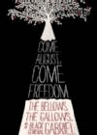 1 of 1 available Checkout / Hold
- Reading List Come August, come freedom the bellows,... Amateau, Gigi, 1964- Info Open Book Imagines the childhood and youth of "Prosser's Gabriel", a courageous and intelligent blacksmith in post-Revolutionary... Average Rating Reviews: 0
- 1 of 1 available Checkout / Hold
- Reading List The Czech Republic Docalavich, Heather. Info Open Book Presents the history, culture, economy, and government of The Czech Republic, and describes major cities, landscape,... Average Rating Reviews: 0
- 1 of 1 available Checkout / Hold
- Reading List Germany Walker, Ida. Info Open Book Presents the history, culture, economy, and government of Germany, and describes major cities, landscape, people,... Average Rating Reviews: 0
- 1 of 1 available Checkout / Hold
- Reading List Glitter Girl Runkle, Toni. Info Open Book Picked by a new cosmetics company to pre-test their products and blog her reviews, Kat Connors's popularity skyrockets,... Average Rating Reviews: 0
- 1 of 1 available Checkout / Hold
- Reading List The infects Beaudoin, Sean. Info Open Book Sixteen-year-old Nick "Nero" Sole is stuck in the woods with the other kids who have survived when zombies attack and... Average Rating Reviews: 0
- 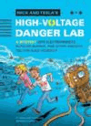 1 of 1 available Checkout / Hold
- Reading List Nick and Tesla's high-voltage danger... Pflugfelder, Bob, 1967- Info Open Book After moving in with their eccentric uncle, Nick and Tesla encounter strange occurrences in their new neighborhood and... Average Rating Reviews: 0
- 1 of 1 available Checkout / Hold
- Reading List The princess in the opal mask Lundquist, Jenny. Info Open Book Elara, an orphan, and Princess Wilha are both searching for their identities and meet face-to-face when an assassination... Average Rating Reviews: 0
- 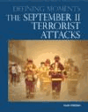 1 of 1 available Checkout / Hold
- Reading List The September 11 terrorist attacks Hillstrom, Kevin, 1963- Info Open Book "Provides a comprehensive account of the origins of Islamic radicalism; the development of Osama bin Laden and al-Qaeda... Average Rating Reviews: 0
- 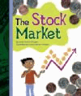 1 of 1 available Checkout / Hold
- Reading List The stock market Brennan, Linda Crotta. Info Open Book An illustrated introduction to the stock market, looking at investing, shares, dividends, and more. Average Rating Reviews: 0
- 1 of 1 available Checkout / Hold
- Reading List Taxes Brennan, Linda Crotta. Info Open Book An illustrated introduction to taxes, examining the different types and what they are used for. Average Rating Reviews: 0
- 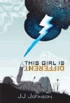 1 of 1 available Checkout / Hold
- Reading List This girl is different Johnson, J. J., 1973- Info Open Book Having always been home schooled by her counter-culture mother, Evie has decided to spend her senior year at the local... Average Rating Reviews: 0
- 1 of 1 available Checkout / Hold
- Reading List United Kingdom Simons, Rae, 1957- Info Open Book Presents the history, culture, economy, and government of the Unied Kingdom, and describes major cities, landscape,... Average Rating Reviews: 0
- 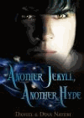 1 of 1 available Checkout / Hold
- Reading List Another Jekyll, another Hyde Nayeri, Daniel. Info Open Book Thomas struggles to accept his billionaire father's marriage to governess Nicola Vileroy and begins to spend less time... Average Rating Reviews: 0
- 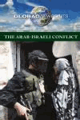 1 of 1 available Checkout / Hold
- Reading List The Arab-Israeli conflict Noah Berlatsky, book editor. Info Open Book Contains twenty-four essays in which the authors examine regional issues and the Arab-Israeli conflict, Israel and the... Average Rating Reviews: 0
- 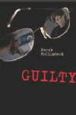 Unlimited copies Checkout / Hold
- Reading List Guilty McClintock, Norah. Info Open Book After Finn's stepmother is allegedly murdered by Lila's father, the two teens must work together to see what is true, and... Average Rating Reviews: 0
- 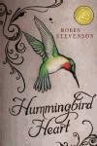 1 of 1 available Checkout / Hold
- Reading List Hummingbird heart Stevenson, Robin, 1968- Info Open Book Dylan is sixteen when she first meets her father, who is looking for a donor match for his sick toddler. Average Rating Reviews: 0
- 1 of 1 available Checkout / Hold
- Reading List An illustrated timeline of space... Wooster, Patricia. Info Open Book An illustrated timeline of space exploration that highlights key moments and developments from ancient times to the early... Average Rating Reviews: 0
- 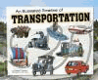 1 of 1 available Checkout / Hold
- Reading List An illustrated timeline of transportation Spengler, Kremena. Info Open Book Follows a single, illustrated time line that provides interesting facts about important moments in the history of... Average Rating Reviews: 0
- 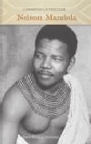 1 of 1 available Checkout / Hold
- Reading List Nelson Mandela Sawyer, Kem Knapp. Info Open Book A biography of Nelson Mandela, first president of democratic South Africa, discussing his childhood in apartheid, his... Average Rating Reviews: 0
- 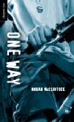 Unlimited copies Checkout / Hold
- Reading List One way McClintock, Norah. Info Open Book When Kenzie critically injures his ex-girlfriend, suspicion grows that it was not an accident, and his behavior seems to... Average Rating Reviews: 0
- 1 of 1 available Checkout / Hold
- Reading List Sharpshooter Lynch, Chris, 1962- Info Open Book Ivan fearlessly enlists in the United States Army in hopes of becoming a war hero like his father, but after being... Average Rating Reviews: 0
- 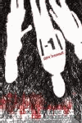 Unlimited copies Checkout / Hold
- Reading List The absolute value of -1 Brezenoff, Steven. Info Open Book Four teenagers relate their experiences as they try to cope with problems in school and at home by smoking, drinking,... Average Rating Reviews: 0
- 1 of 1 available Checkout / Hold
- Reading List Curveball the year I lost my grip Sonnenblick, Jordan. Info Open Book After an injury ends former star pitcher Peter Friedman's athletic dreams, he concentrates on photography which leads him... Average Rating Reviews: 0
- 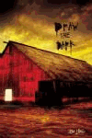 Unlimited copies Checkout / Hold
- Reading List Draw the dark Bick, Ilsa J. Info Open Book Seventeen-year-old Christian Cage lives with his uncle in Winter, Wisconsin, where his nightmares, visions, and strange... Average Rating Reviews: 0
- 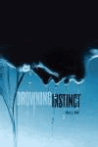 Unlimited copies Checkout / Hold
- Reading List Drowning instinct Bick, Ilsa J. Info Open Book An emotionally damaged sixteen-year-old girl begins a relationship with a deeply troubled older man. Average Rating Reviews: 0
- 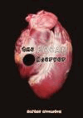 Unlimited copies Checkout / Hold
- Reading List The freak observer Woolston, Blythe. Info Open Book Suffering from a crippling case of post-traumatic stress disorder, sixteen-year-old Loa Lindgren tries to use her problem... Average Rating Reviews: 0
- 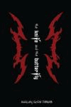 Unlimited copies Checkout / Hold
- Reading List The knife and the butterfly Pérez, Ashley Hope. Info Open Book After a brawl with a rival gang, sixteen-year-old Azael, a member of Houston's MS-13 gang and the son of illegal... Average Rating Reviews: 0
- 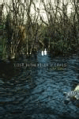 Unlimited copies Checkout / Hold
- Reading List Lost in a river of grass Rorby, Ginny. Info Open Book When two Florida teenagers become stranded on a tiny island in the Everglades, they attempt to walk ten miles through... Average Rating Reviews: 0
- 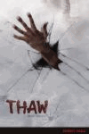 Unlimited copies Checkout / Hold
- Reading List Thaw Jasper, Rick, 1948- Info Open Book After a storm causes a power outage at the Institute for Cryogenic Experimentation, the thawed-out bodies of twenty-seven... Average Rating Reviews: 0
- 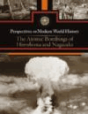 1 of 1 available Checkout / Hold
- Reading List The atomic bombings of Hiroshima and... Sylvia Engdahl, book editor. Info Open Book A collection of essays that examines the atomic bombings of Hiroshima and Nagasaki, providing historical background... Average Rating Reviews: 0
- 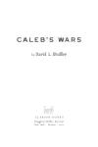 1 of 1 available Checkout / Hold
- Reading List Caleb's wars Dudley, David L. Info Open Book Fifteen-year-old Caleb's courageous commitment to justice grows as he faces a power struggle with his father, fights to... Average Rating Reviews: 0
- 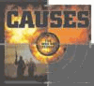 1 of 1 available Checkout / Hold
- Reading List Causes Wimmer, Teresa, 1975- Info Open Book "An examination of events that helped create the ongoing war against Islamic extremists, from early-20th-century Western... Average Rating Reviews: 0
- 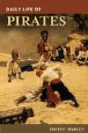 1 of 1 available Checkout / Hold
- Reading List Daily life of pirates Marley, David, 1950- Info Open Book Examines typical activities in the daily lives of pirates, describing food and beverage, weapons and seamanship,... Average Rating Reviews: 0
- 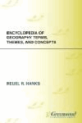 1 of 1 available Checkout / Hold
- Reading List Encyclopedia of geography terms,... Hanks, Reuel R. Info Open Book Contains over one hundred and fifty alphabetically arranged entries that provide information related to geographical... Average Rating Reviews: 0
- 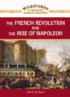 1 of 1 available Checkout / Hold
- Reading List The French Revolution and the rise of... Davenport, John, 1960- Info Open Book Traces the history of the French Revolution, from 1789 to 1799, during which the French people rose up against the ruling... Average Rating Reviews: 0
- 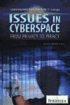 Unlimited copies Checkout / Hold
Reading List Issues in cyberspace from privacy to piracy edited by Robert Curley. Info Open Book An introduction to internet topics, including privacy, piracy, blogging, cybercrime, and distance learning. Average Rating Reviews: 0

